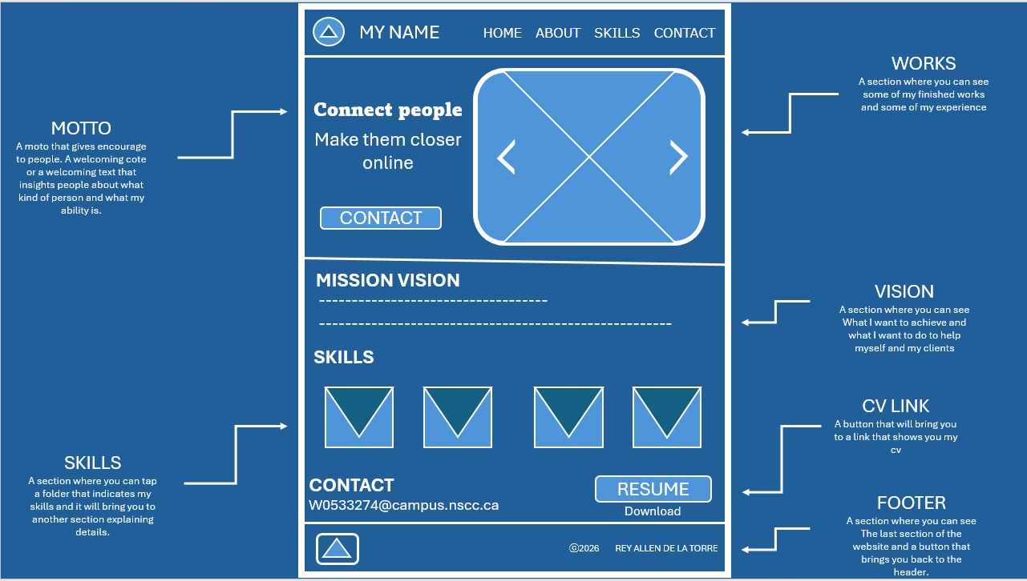
REY ALLEN’s Portfolio-Design

